Multiple Choice Questions

1) | Threonine is converted into acetyl-CoA and pyruvate while proline is converted into α-ketoglutarate. Classify each of these amino acids.

A) | threonine is ketogenic, proline is ketogenic
B) | threonine is ketogenic and glucogenic, proline is ketogenic
C) | threonine is ketogenic, proline is glucogenic
D) | threonine is ketogenic and glucogenic, proline is glucogenic
E) | none of the above

Answer: D

Difficulty: 2 Topic: Pathways of Amino Acid Degradation

2) | Which pair of amino acids can be degraded to oxaloacetate and α-ketoglutarate, respectively?

A) | aspartate, alanine
B) | asparagine, histidine
C) | histidine, serine
D) | proline, arginine
E) | threonine, glutamine

Answer: B

Difficulty: 2 Topic: Pathways of Amino Acid Degradation

3) | The route by which methionine is degraded provides for the synthesis of which amino acid?

A) | serine
B) | threonine
C) | valine
D) | isoleucine
E) | cysteine

Answer: E

Difficulty: 2 Topic: Pathways of Amino Acid Degradation

4) | The catabolism of leucine to acetyl-CoA produces three molecules of acetyl-CoA, one NADH, and one FADH₂,while consuming two ATP. What is the net ATP production from the complete oxidation of the leucine carbon skeleton?

A) | 30
B) | 32
C) | 34
D) | 36
E) | none of the above

Answer: B

Difficulty: 3 Topic: Pathways of Amino Acid Degradation

5) | Which amino acids are transaminated by the branched-chain amino acid aminotransferase?

A) | valine, isoleucine and leucine
B) | proline, valine and alanine
C) | leucine, isoleucine and phenylalanine
D) | leucine, isoleucine and proline
E) | lysine, valine and leucine

Answer: A

Difficulty: 2 Topic: Pathways of Amino Acid Degradation

6) | One route for tryptophan degradation leads to the coenzyme _____________.

A) | pyridoxal phosphate
B) | FAD
C) | NAD⁺
D) | tetrahydrobiopterin
E) | none of the above

Answer: C

Difficulty: 2 Topic: Pathways of Amino Acid Degradation

7) | In the pathway for conversion of phenylalanine to fumarate and acetoacetate, there are two well-known enzyme defects that cause inheritable metabolic diseases. What are the names of these two diseases?

A) | homocysteinuria and nonketotic hyperglycinemia
B) | phenylketonuria and maple syrup urine disease
C) | alkaptonuria and nonketotic hyperglycinemia
D) | alkaptonuria and phenylketonuria
E) | maple syrup urine disease and homocysteinuria

Answer: D

Difficulty: 2 Topic: Pathways of Amino Acid Degradation

8) | The regeneration of methionine from homocysteine relies upon the conversion of _________ to __________ as a source of carbon.

A) | alanine; pyruvate
B) | phenylalanine; tyrosine
C) | cystathionine; cysteine
D) | proline; glutamate
E) | serine; glycine

Answer: E

Difficulty: 2 Topic: Amino Acids as Biosynthetic Precursors

9) | The importance of regenerating methionine can be seen in the multiple methionine regeneration pathways found in the liver, such as the pathway that uses betaine as a methyl group donor. What glycerophospholipid component is the precursor for betaine?

A) | ethanolamine
B) | glycerol
C) | choline
D) | serine
E) | none of the above

Answer: C

Difficulty: Topic: Amino Acids as Biosynthetic Precursors

10) | Which of the following is a role of spermine and spermidine, the polyamines derived from glutamate?

A) | stabilization of tRNA duplex structure
B) | neutralization of DNA negative charge
C) | stabilization of double stranded DNA
D) | stabilization of bacterial membranes
E) | all of the above

Answer: E

Difficulty: 2 Topic: Amino Acids as Biosynthetic Precursors

11) | Of the following molecules derived from amino acids, which is used to transport amino acids across the cell membrane?

A) | glutathione
B) | γ-aminobutyric acid
C) | S-adenosylmethionine
D) | nitric oxide
E) | thyroxine

Answer: A

Difficulty: 1 Topic: Amino Acids as Biosynthetic Precursors

12) | Which of the following molecules derived from tyrosine is correctly defined?

A) | dopamine: thyroid hormone
B) | dopaquinone: precursor for melanins
C) | thyroxine: catecholamine
D) | norepinephrine: thyroid hormone
E) | all of the above

Answer: B

Difficulty: 2 Topic: Amino Acids as Biosynthetic Precursors

13) | In animals, all nitrogen and carbon of heme groups comes from the reaction of the amino acid ________ and _________.

A) | glutamate; malonyl-CoA
B) | aspartate; acetyl-CoA
C) | asparagine; propionyl-CoA
D) | glycine; succinyl-CoA
E) | alanine; methylmalonyl-CoA

Answer: D

Difficulty: 2 Topic: Porphyrin and Heme Metabolism

14) | Which of the following explains the unique mechanism by which δ-aminolevulinic acid is synthesized in most bacteria, archaea and plants?

A) | glutamic acid is attached to its tRNA and then reduced to glutamate-1-semialdehyde
B) | glutamic acid undergoes reduction and cyclization to Δ¹-pyrroline-5-carboxylate
C) | glutamic acid undergoes carboxylation to γ-carboxyglutamic acid
D) | glutamic acid condenses with itself via the δ-carboxyl and amine group
E) | none of the above

Answer: A

Difficulty: 2 Topic: Porphyrin and Heme Metabolism

15) | Bilirubin is conjugated with _________ to increase its solubility for excretion.

A) | phospholipids
B) | glycine
C) | glucuronic acid
D) | taurine
E) | all of the above

Answer: C

Difficulty: 1 Topic: Porphyrin and Heme Metabolism

16) | The conversion of tryptophan to 5-hydroxytryptophan in the serotonin synthesis pathway is analogous to the conversion of _________ to _________.

A) | glycine; serine
B) | phenylalanine; tyrosine
C) | tyrosine to thyroxine
D) | dopa to dopaquinone
E) | all of the above

Answer: B

Difficulty: 2 Topic: Amino Acids and Their Metabolites as Neurotransmitters

17) | Which of the following amino acids is derived from a glycolytic intermediate?

A) | aspartate
B) | threonine
C) | proline
D) | arginine
E) | serine

Answer: E

Difficulty: 2 Topic: Amino Acid Biosynthesis

18) | In bacteria, the biosynthetic routes for proline and arginine diverge when glutamate is N-acetylated for arginine synthesis. Which of the following explains why acetylation is required for arginine synthesis but not proline synthesis?

A) | acetylation alters the pK_{a} of the amine group
B) | acetylation prevents reduction of the amine group in N-acetylglutamate-δ-semialdehyde
C) | acetylation activates the amine group for synthesis of the guanidine group of arginine
D) | acetylation prevents the cyclization of N-acetylglutamate-δ-semialdehyde
E) | none of the above

Answer: D

Difficulty: 3 Topic: Amino Acid Biosynthesis

19) | Glyphosate, the active molecule in the herbicide Roundup®, is an inhibitor of the enzyme 5-enolpuruvylshikimate-3-phosphate synthase in the chorismate synthesis pathway. Which of the following amino acids would not be produced in a plant treated with Roundup®?

A) | glycine
B) | serine
C) | tyrosine
D) | valine
E) | proline

Answer: C

Difficulty: 2 Topic: Amino Acid Biosynthesis

20) | Which of the following molecules uses chorismate as a precursor?

A) | p-aminobenzoic acid
B) | coenzyme Q
C) | phenylalanine
D) | tryptophan
E) | all of the above

Answer: E

Difficulty: 1 Topic: Amino Acid Biosynthesis

21) | Which amino acid utilizes nitrogen and carbon from adenine in the synthesis of its R-group?

A) | histidine
B) | arginine
C) | lysine
D) | asparagine
E) | all of the above

Answer: A

Difficulty: 2 Topic: Amino Acid Biosynthesis

22) | The Ames test is used to measure the mutagenicity of molecules by introducing a potential mutagen to a culture of bacteria that cannot synthesize histidine. Which of the following explains the results if the bacteria are able to grow in a medium that lacks histidine?

A) | all proteins expressed by the bacteria have mutated to not require histidine
B) | defective histidine synthesis genes are mutated to forms that allow for histidine synthesis
C) | the mutagen causes the bacteria to use some other molecule in place of histidine
D) | the bacteria can convert the potential mutagen into histidine
E) | none of the above

Answer: B

Difficulty: 2 Topic: Amino Acid Biosynthesis

Short Answer Questions

1) Provide the two missing items in the scheme that shows the metabolism of threonine to glycine.

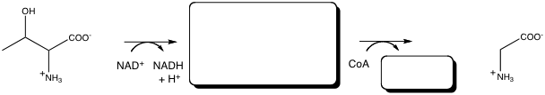

Answer:

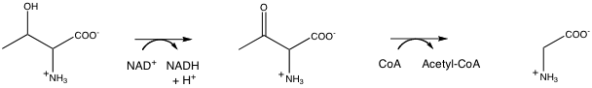

Difficulty: 2 Topic: Pathways of amino acid degradation

2) Give the products of the following reaction in the γ-glutamyl cycle. One product is an amino acid, the other, 5-oxoproline.

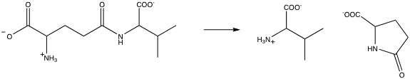

Answer:

Difficulty: 3 Topic: Amino Acids as Biosynthetic Precursors

3) Tryptophan is converted to serotonin, also known as 5-hydroxytryptamine. Show the intermediate and the product in the following synthetic pathway.

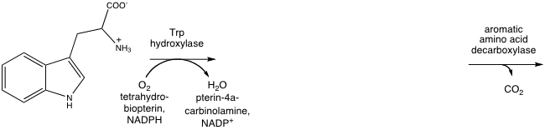

Answer:

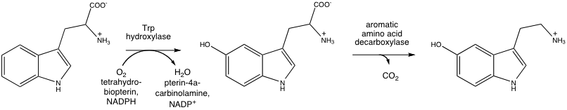

Difficulty: 3 Topic: Amino Acids and Their Metabolites as Neurotransmitters

